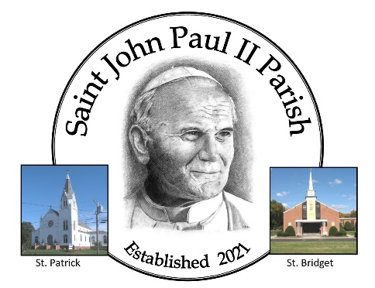
SAINT JOHN PAUL II PARISH
47 West High St., E. Hampton, CT 06424 860-267-6644

Churches of:
ST. BRIDGET OF KILDARE and ST. PATRICK

CERTIFICATE OF ELIGIBIITY FOR:
Baptism Confirmation

Witness/Sponsor for:________________________________________________________
(Name of person being baptized or confirmed)

Scheduled Date of Ceremony: _________________________________________________

Location of Ceremony: ______________________________________________________

SPONSOR INFORMATION:

I, ________________________________________________ RESIDING AT:
(Please PRINT first and last name)
Address: _________________________________________________________________

Registered and Attending Mass at: ____________________________________________
(Church Name, Town and State)

Affirm that:

I am at least 16 years of age, I am a practicing Catholic, and I have received the
sacraments of Baptism, First Holy Communion and Confirmation in the Catholic Church.

I participate in the Mass on Sundays and Holydays and receive the Sacraments of
Eucharist and Reconciliation regularly.

If married, I am validly married according to the laws of the Catholic Church.

I actively strive to live out my commitment to Christ and to the community life of the
Church by my loving response to those with whom I come in contact.

I realize that I assume a greater responsibility before God and the Church in becoming a sponsor and will faithfully fulfill the obligations connected with it. I will give support to the person I am sponsoring by my prayers and by the Christian example of my daily life.

By my signature, I attest to the truth of these statements:

________________________________________________ Date: _____________________
(Sponsor’s signature)

TO BE COMPLETED BY THE SPONSOR’S PARISH PARISH SEAL:

Priest Signature:__________________________________
(Must be signed by a Roman Catholic Priest)
Date: ___________________________________________ (SEAL required for valid documentation)

